Ahn, Harry

Professor John

Differential Equations

Rocket Propulsion Report

For my project, I will be calculating the changes of velocity, mass, and momentum of a

rocket as it accelerates. Majority of the mass of a rocket is fuel and therefore as the rocket

accelerates, it loses mass. The purpose of this project is to show and derive the expression that

illustrates the change in velocity of a rocket to the change in its mass as well as all of the other

forces acting on it.

The Rocket Propulsion can be viewed analytically by using Newton’s Second Law which states that F=dP/dT. It can be stated that “the resultant of the forces acting on a particle is equal to the rate of change of the linear momentum of the particle” . With the knowledge of F=dP/dT from newton’s second law, it can’t directly used in the case of rocket propulsion because it’s mass is constantly changing. Hence, F= dP/dT needs to be altered so that the change in mass can be considered.

**(ΔP/ΔT) = F**

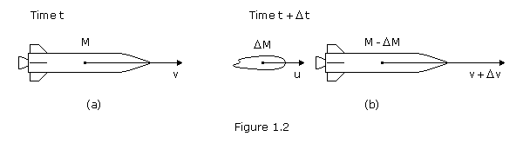

Looking at this figure, we can see that the momentum initially, can be calculated by multiplying the Mass and Velocity. After a change in Time, the Mass of the total rocket system will not be it’s initial mass but rather a smaller Mass (M + ΔM) because the fuel is constantly burning which causes the Mass of the rocket system to become smaller. As the Rocket gets lighter, in order for the equation to be balanced, the acceleration of the rocket will increase and so will the velocity. In addition to the change in the momentum of the rocket system, the momentum of the exhaust gas needs to be considered because this is what is giving the rocket thrust to move upward.

**ΔP = P2 - P1= ( M + ΔM )( V + ΔV )- MV = MΔV + VΔM +ΔMΔV**

This equation is calculating the change in momentum by assuming the changes in mass by ΔM and ΔV respectively

We also have to take into consideration the momentum of the exhaust (relative to the rocket )

which gives the rocket speed. Therefore the momentum of the exhaust is

**Momentum = - ΔMass of fuel ( velocity of rocket - velocity of exhaust )**

**V - C**

Eventually the rocket’s overall mass will drop to just the mass of the rocket and it will no longer carry the mass of the fuel.

Adding the momentum of the exhaust gas gives :

**ΔP = ( MΔV + VΔM + ΔMΔV ) + ( -ΔM )( V-C ) = MΔV + CΔM + ΔMΔV**

*# Note # C is the exhaust velocity of the rocket*

In order to produce a differential equation from the new ΔP equation, it needs to be divided by change in Time which results:

**M (ΔV/ΔT) + C (ΔM/ΔT) = F**

Knowing that F = Force of gravity + Force of air resistance

Force of Gravity = -Mg

Force of Air resistance = -Kv^p

M (ΔV/ΔT) + C (ΔM/ΔT) = -Mg - KV^p

In the book, it assumes that the exponent of the velocity is 1, however the exponent value of p is dependent on several circumstances

The rocket propulsion in the textbook neglects the exponent coefficient of velocity which depends on the altitude and the velocity of the rocket. the exponent coefficient of the velocity changes as the rocket is in motion. At low speeds air resistance is proportional to the first power of velocity. When velocity reaches the point where turbulence is generated , the air resistance is proportional to the square of the velocity ( p=2) .Also as the rocket travels higher up in the air, the density of air decrease because there is less air pushing down and gravity is weaker. There are less air molecules present which means the rocket will be hitting less air molecules compared to a much lower altitude. So in conclusion, when the rocket initially lifts off, the p value will start at 0 because the rocket starts at rest, then it will increase to 1 as the rocket slowly moves upwards. When it reaches a high enough velocity it will experience turbulence so the exponent coefficient will then be 2. As the rocket continues to go higher and higher up into altitude, it will hit less air molecules which will slowly decrease the p value to 0 because there are no more air molecules in space.

**Diagram of how the air resistance exponent coefficient of velocity changes :**

With the coefficient of P in mind, Now suppose the rocket fuel is being used at a constant burn rate B during the time interval of [0,T1]. During the time interval of [0,T1] the mass will change from Mo to M1 because the fuel loss cause the mass to become smaller.

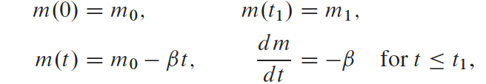

By plugging these values into



The new differential equation will be

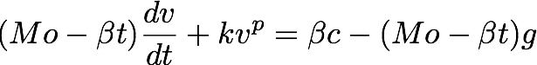

An Abstract view of this equation: A Rocket with fuel of initial Mass Mo is ejecting fuel at a constant rate of B ( Burn Rate ). The combustion of fuel ejects gas in downward direction with a constant speed of c. As a result the ejecting gas from the fuel creates an upward force on the rocket which describes Momentum (P). Another force that acts on the rocket as it is in upward motion is the force of gravity, which is constantly applied until the rocket reaches outer space where there is no gravity.

The derivative of the velocity equation which will be useful in the euler’s method for estimation, but integrating that differential equation can will provide me the velocity equation of a rocket ( not neglecting air resistance ). The integrating factor and some integration rules will be applied to integrate the acceleration of the rocket.

I will be using jupyter notebook to code the velocity of the rocket at a given time( problem 4 from application 2.3). From the Euler method code created by Professor John, I inputted the necessary variables and data into the code.



From this equation the derivative of velocity can be derived which is

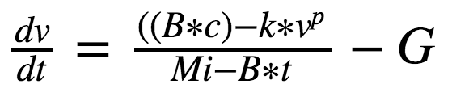

The reason why the derivative of velocity is important is because the euler method requires the slope of velocity and it also makes input of data within the code easier to compute. Euler method is important to estimate the value of velocity in this equation because I incorporated a p exponent to the velocity. This P exponent is correlated with air resistance, velocity, and altitude. When the rocket is within earth’s atmosphere, there are enough air molecules to be a resistant towards the upward movement of the rocket. However, when the rocket leaves earth’s atmosphere, there will be no atmosphere when the p value will be 0. Another factor the p value is dependent on is the velocity of the rocket. When the rocket is moving at a speed that is not enough to cause turbulence ( in the beginning of lift off) the p value stays between 0 and 1 but when it reaches a high velocity at a certain velocity, the p value will be around 2. In order to account this information into the code, I made a distinction that if the velocity is traveling at a speed les than or equal to 300 m/s the p value will be 1. If the rocket is traveling greater than 300 m/s and less than 700 meters per second, the p value will be 1.5. Lastly, if the rocket is traveling greater than 700 m/s the p value will be 2.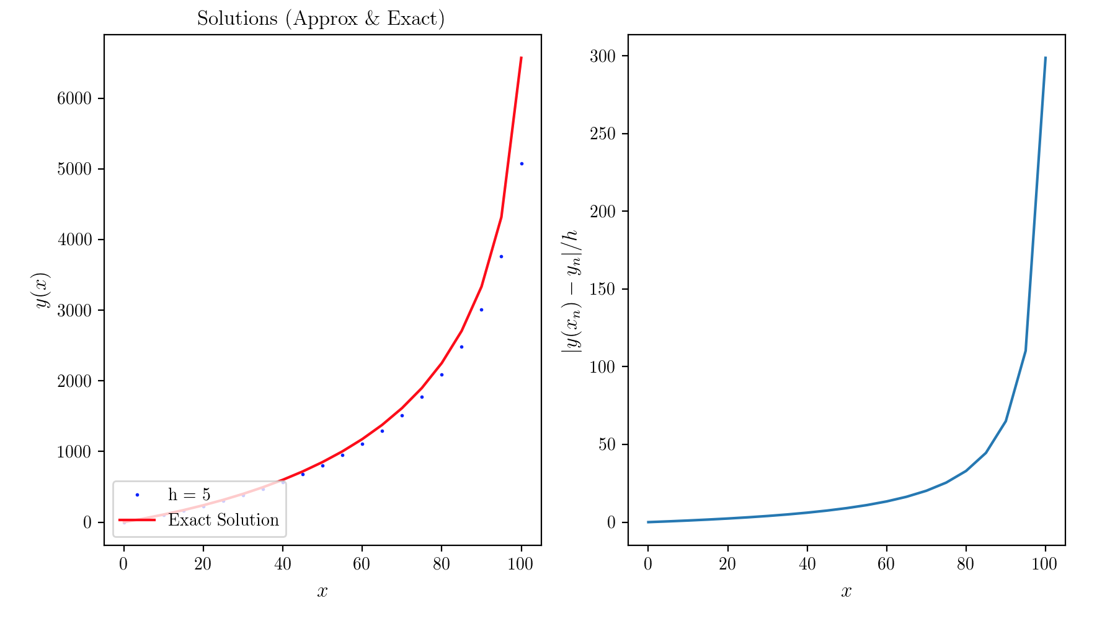

From the Graphs that my code produces, the blue dots/line shows the estimates euler solution with varying step sizes ( in this case 5), and in comparison also shows the exact solution to see the amount of error between the two curve. The graph to the right shows the actual amount value error between the the two curves in the left graph.

This topic is important because the differential equation of a rocket propulsion is complicated version of a projectile motion that incorporate air resistance and change in mass due

to the fuel. Learning about my project will help my peers to understand the physics and the math

behind most projectile motion equations with ease.